

Foundations of Programming

Assignment No.: 06
PROBLEM STATEMENT: Write a C function to compute the factorial of a number with and without recursion.

OBJECTIVE:

To demonstrate two different approaches for calculating the factorial of a number: iterative (non-recursive) and recursive, showcasing the versatility of problem-solving methods in programming.

THEORY:
- Explain the difference between the iterative and recursive approaches to calculating the factorial of a number.
The factorial of a number $n$(written as $n!$) is the product of all positive integers from 1 to $n$.
For example:
$$5!=5×4×3×2×1=120$$
There are two common ways to calculate factorials in programming: iterative and recursive approaches.

1️⃣ Iterative Approach
🔹 Definition
The iterative method uses a loop (such as for or while) to repeatedly multiply numbers until the result is obtained.
🔹 How It Works
- Start with a result variable (usually set to 1).
- Use a loop to multiply the result by each number from 1 to $n$.
- Return the final result.
🔹 Example (Pseudocode)
function factorial(n):
result = 1
for i from 1 to n:
result = result * i
return result
🔹 Characteristics
- Uses loops.
- Generally more memory-efficient.
- Faster in many cases.
- No risk of stack overflow.

2️⃣ Recursive Approach
🔹 Definition
The recursive method solves the problem by calling itself with a smaller value until it reaches a base case.
🔹 Mathematical Idea
Factorial is naturally defined recursively:
- Base case:
$$0!=1$$
- Recursive case:
$$n!=n×(n-1)!$$
🔹 Example (Pseudocode)
function factorial(n):
if n == 0:
return 1
else:
return n * factorial(n - 1)
🔹 Characteristics
- Function calls itself.
- Requires a base case to stop recursion.
- Uses more memory due to the call stack.
- Can cause stack overflow for large $n$

- What is the base case in the recursive function for computing factorials, and why is it necessary?
The base case in the recursive function for computing factorials is

(Or

), which returns a value of
.
1. Define the base case
In mathematics, the factorial of a non-negative integer
is defined by the recurrence relation

. To prevent this process from continuing infinitely, a termination point must be established. Since

is defined as
, the base case is:

2. Prevent infinite recursion
Without a base case, the function would continue to call itself with increasingly smaller (negative) numbers (

). In computing, this leads to a stack overflow error, as the computer exhausts its memory trying to keep track of an infinite chain of function calls.
3. Provide a concrete value
Recursion works by breaking a complex problem into simpler versions of itself. However, these sub-problems must eventually resolve to a known constant. The base case provides the first actual number (
) That can be multiplied by the previous results to "unwind" the recursion and calculate the final product

- How does the program handle invalid input, such as negative numbers, and why is this important?
Programs handle invalid input through input validation, which ensures data meets specific criteria before it is processed.
How Programs Handle Invalid Input
- Conditional Logic: Programs often use if/else statements to check if a value is negative. If it is, they may block the operation and display an error message.
- Validation Loops: Many applications use a while loop to repeatedly prompt the user for input until they provide a valid positive number.
- Exception Handling: In languages like C# or Java, programs use try-catch blocks to catch errors if a user enters a non-numeric character or a value that triggers a custom "Negative Number Exception".
- Input Sanitization: Some programs automatically modify invalid input, such as using the Math. Abs() function to convert a negative number into its positive equivalent.
Why Input Validation is Important
- Prevents Crashes: Without validation, unexpected data types or values can cause a program to terminate abruptly.
- Maintains Data Integrity: Validating inputs prevents "garbage in, garbage out," ensuring that databases do not get corrupted by incorrect or illogical values.
- Security: Proper validation is the first line of defence against cyberattacks like SQL injection and buffer overflows, where attackers use malicious input to gain unauthorized access.
- Business Logic Integrity: In financial or e-commerce apps, failing to check for negative numbers could allow users to accidentally (or maliciously) trigger refunds or manipulate account balances.
- User Experience: Clear error messages help users understand exactly what went wrong and how to fix it, reducing frustration.
ALGORITHM
1. Algorithm (Without Recursion / Iterative)
Steps:
- Start
- Input number n
- Initialize fact = 1
- Repeat from i = 1 to n:
  - fact = fact * i
- Print fact
- Stop
2. Algorithm (With Recursion)
Steps:
- Start
- Input number n
- If n == 0 or n == 1, return 1
- Else return n * factorial(n-1)
- Stop

PLATFORM: Linux

INPUT:
OUTPUT:
CONCLUSION: Thus, we have successfully executed factorial of a number with and without recursion.

CODE AND OUTPUT FOR THE ABOVE PROBLEM STATEMENT IS GIVEN

Through iterative method

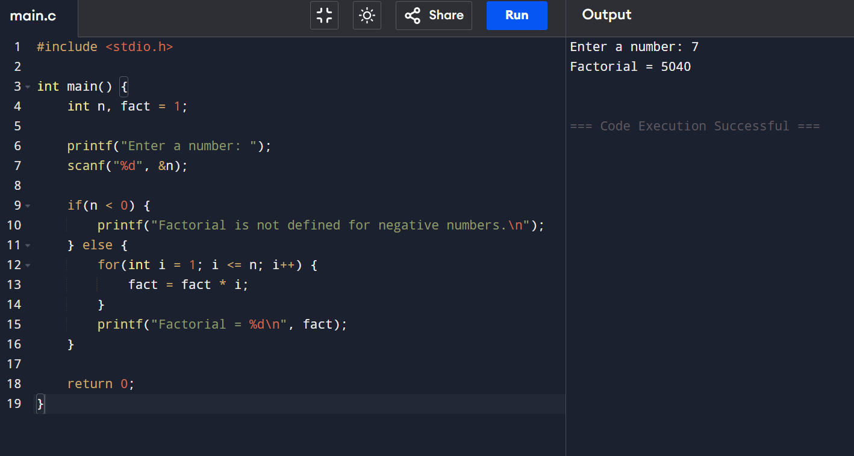

Through recursive method

